8D TECHNICAL ANALYSIS
Elimination of “UNKNOWN FAILURE” via Invariant Signal Diagnostics (Sigma-R)
Pilot Device: J2-Class Joystick

D1 — PROBLEM DESCRIPTION (8D CONTEXT)
D1.1 Problem Statement
A significant proportion of J2-class joystick returns are currently classified as UNKNOWN FAILURE.
These returns exhibit the following characteristics:
- No mechanical damage observed
- Electrical parameters within specification on bench test
- Customer reports of drift, instability, or offset over time
- Failure not reproducible under teardown or static inspection
This failure category provides no actionable diagnostic information, results in repeated “no fault found” loops, and complicates OEM discussions.

D2 — CURRENT CONTAINMENT AND LIMITATIONS
D2.1 Current 8D Diagnostic Practice
Current analysis relies on:
- Single-channel analog interpretation (typically channel A)
- Static comparison against specification limits
- Post-hoc classification following customer complaint
There is no invariant-based witness, no persistence logic, and no distinction between recoverable drift and inevitable failure.
As a result, all such cases are grouped into UNKNOWN FAILURE, regardless of underlying behavior.

D3 — ROOT CAUSE ANALYSIS (ENGINEERING INTERPRETATION)
D3.1 Structural Root Cause
The dominant UNKNOWN FAILURE pattern is not random defect but loss of functional invariance under system composition.
Small, acceptable variations in gain, offset, temperature, or alignment become externally visible only because the current method does not separate functional position from structural drift.
The issue is therefore observability, not component correctness.

D4 — CORRECTIVE ACTION PROPOSAL (SIGMA-R METHOD)
D4.1 Logged Input Data (Unchanged)
For each time sample t, the following signals are logged (already available today):
- A(t): Analog channel A
- B(t): Analog channel B
- Sᵢ: Reed switch events
- (Optional) V(t), T(t)
No hardware changes and no OEM system access are required.

D4.2 Current 8D Signal Interpretation
Under current practice, position is inferred as:
x_8D(t) ≈ A(t)
This assumes stable gain and offset, which are not verified.
There is no secondary witness to indicate structural change.

D4.3 Sigma-R Signal Interpretation (Proposed)
D4.3.1 Invariant Position Reconstruction
Signals are modeled as:
A(t) = k(t)·x(t) + a₀(t) + n_A(t)
B(t) = −k(t)·x(t) + b₀(t) + n_B(t)
Define the invariant difference:
D(t) = A(t) − B(t)
x_ΣR(t) = D(t) / D_max
Where D_max is fixed at calibration.
Result:
Common-mode gain and offset variations cancel to first order:
∂x_ΣR / ∂k ≈ 0
This prevents benign drift from affecting functional position.

D4.3.2 Structural Witness: Sum Invariant
Define:
S(t) = A(t) + B(t)
At calibration:
S₀ = mean(S(t))
Boundary condition:
|S(t) − S₀| > ε_S for N consecutive samples
This detects structural geometry or coupling drift independent of position.

D4.3.3 Discrete–Analog Consistency
At each reed switch event Sᵢ:
|x_ΣR(tᵢ) − x_exp,i| > ε_R
Detects alignment or magnetic shift without requiring part failure.

D5 — VERIFICATION VIA SIDE-BY-SIDE ANALYSIS (FIGURE-REFERENCED)
The following figures illustrate representative behavior under the stated signal model and calibration assumptions. Threshold values and persistence criteria are product-specific and must be validated against measured noise and tolerance budgets.
D5.1 Diagram: “Current 8D Method (Single Channel) / Sigma-R Method (Invariant)”
This diagram shows two panels derived from the same input data:
- Upper panel: Current 8D method using A(t)
- Lower panel: Sigma-R invariant position x_ΣR(t)
Interpretation:
- Under the current 8D method, the position trace visibly drifts over time.
- Under Sigma-R, the invariant position remains stable and bounded.
Conclusion:
The joystick did not lose positional fidelity.
The observed drift is an artifact of interpretation.
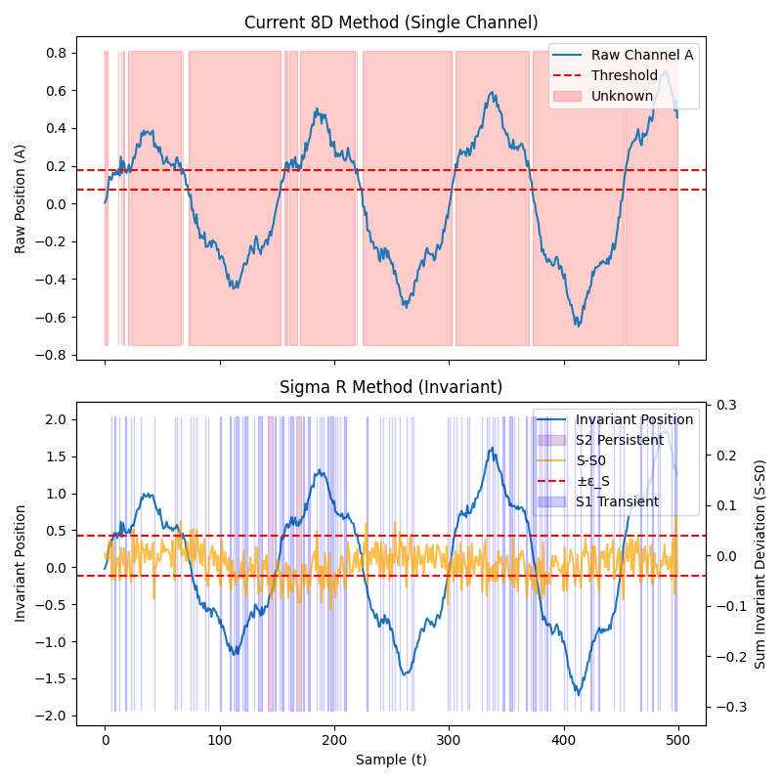
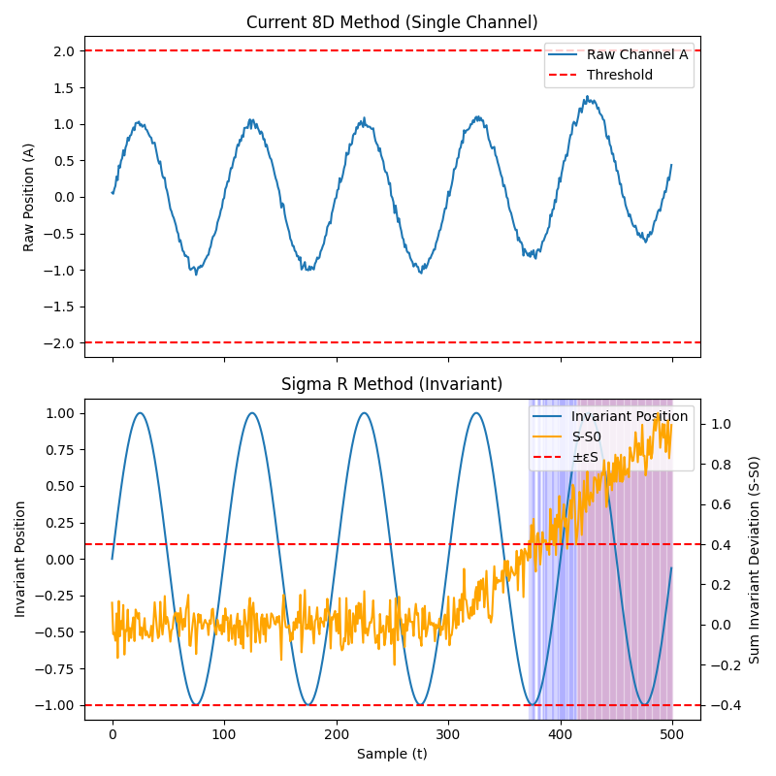

D5.2 Diagram: “Raw vs Invariant Position”
This diagram overlays:
- Raw single-channel position
- Sigma-R invariant position
Interpretation:
- Raw signal exhibits drift due to gain/offset changes.
- Invariant signal tracks the intended motion.
Conclusion:
Sigma-R suppresses irrelevant variation without loss of precision.
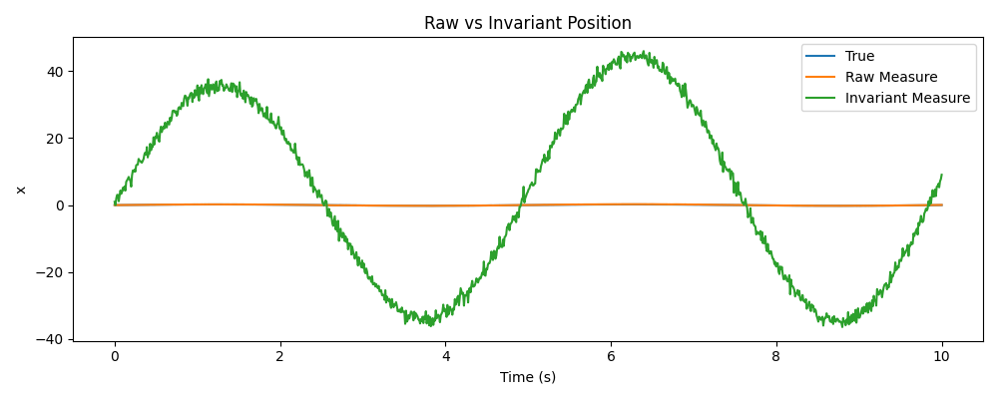

D5.3 Diagram: “Sum Invariant Threshold”
This diagram plots:
S(t) − S₀
with ±ε_S bounds.
Interpretation:
- Early samples remain within bounds (recoverable drift).
- Later samples exceed bounds persistently.
Conclusion:
A deterministic boundary crossing is detected at a specific time.

D6 — FAILURE CLASSIFICATION OUTCOME
D6.1 Current 8D Result
Sql
Failure Class: UNKNOWN
Evidence: None
Onset Time: Unknown

D6.2 Sigma-R Result
Yaml
Failure Class: UF-S2 (Boundary Crossing)
First Violation Time: t₀
Witness: Sum Invariant
Prior State: UF-S1 (Recoverable Structural Drift)
This record is audit-ready and defensible.

D7 — PREVENTION AND SYSTEMIC IMPROVEMENT
D7.1 Material Benefits
Sigma-R provides:
- Reduction in unnecessary returns caused by benign drift
- Clear separation between recoverable and inevitable behavior
- Timestamped, evidence-backed failure records
- Elimination of “no fault found” loops
- Preserved positional precision

D7.2 Implementation Scope
- Firmware / signal interpretation only
- No hardware changes
- No OEM system knowledge required
- Pilot limited to J2-class joystick

FINAL 8D CONCLUSION
The “UNKNOWN FAILURE” category exists because the current 8D method observes raw signal change without structural context.
The Sigma-R method introduces invariant reconstruction and structural witnesses already latent in the signal, converting ambiguity into deterministic engineering classifications.
The diagrams titled:
- “Current 8D Method (Single Channel) / Sigma-R Method (Invariant)”
- “Raw vs Invariant Position”
- “Sum Invariant Threshold”
demonstrate this outcome unequivocally.
This constitutes a corrective and preventive action at the diagnostic level, not a redesign.

Mapping Sigma-R Data Requirements to an EOL Tester
1. What an EOL tester already has (baseline reality)
A typical joystick EOL tester already does the following:
- Powers the joystick
- Commands or stimulates motion (manual or fixture-based)
- Reads analog outputs (at least one, often more)
- Reads discrete outputs (reed switches, buttons)
- Compares readings against high/low functional limits
- Produces a PASS / FAIL result
Sigma-R does not change any of that.
Sigma-R only changes what is logged and how it is interpreted.

2. Required EOL signal hookups (no hardware change)
2.1 Analog Channel A → A(t)
Already present
- Source: Hall sensor / analog output channel A
- Typical connection:
  - EOL analog input AI-A
- Units:
  - Voltage or ADC counts
✅ Action required:
Ensure this channel is logged as a time series, not just min/max.

2.2 Analog Channel B → B(t)
Already present on redundant joysticks, often unused
- Source: Second Hall sensor / redundant output
- Typical connection:
  - EOL analog input AI-B
- Units:
  - Voltage or ADC counts
⚠️ Common gap today:
Channel B is often wired but not logged or only used for plausibility.
✅ Action required:
Log AI-B synchronously with AI-A.

2.3 Time Index → t
- Source:
  - EOL tester internal clock or sample counter
- Resolution:
  - Whatever the EOL tester already uses (e.g., 10–100 Hz)
✅ Action required:
Ensure samples are stored in order with a sample index.
Absolute timestamps are not required.

3. Calibration window in the EOL test
Sigma-R requires a known-good reference window.
3.1 Where this fits in the EOL flow
Typical EOL flow already has:
- Power-up
- Stabilization
- Initial read
- Functional sweep / interaction
- Pass / fail evaluation
✅ Sigma-R calibration window = step 2–3
(early samples before full actuation)

3.2 What is computed during calibration
From the calibration window:
Scss
S0 = mean(A(t) + B(t))
Dmax = expected max |A(t) − B(t)|
✅ Action required:
Store S0 and Dmax as test metadata.
No new measurements needed.

4. Sigma-R computations (done offline or inline)
These do not require real-time execution during EOL unless desired.
4.1 Functional invariant (position)
Computed from logged data:
Scss
D(t) = A(t) − B(t)
xΣR(t) = D(t) / Dmax
✅ Mapping:
Uses AI-A and AI-B only.

4.2 Structural witness (sum invariant)
Computed from the same data:
Scss
S(t) = A(t) + B(t)
ΔS(t) = S(t) − S0
✅ Mapping:
No additional inputs.

5. Thresholds and logic (configuration parameters)
These are tester configuration values, not signals.
5.1 Structural threshold εS
- Defined in:
  - Voltage or ADC counts
- Derived from:
  - ADC noise
  - Thermal variation
  - Expected elastic tolerance
✅ Mapping:
Stored as a tester parameter (like existing limits).

5.2 Persistence count N
- Defined in:
  - Number of consecutive samples
- Meaning:
  - How long ΔS(t) must remain outside ±εS to declare S2
✅ Mapping:
Implemented as a simple counter in test software or offline analysis.

6. Discrete signals (optional but recommended)
6.1 Reed switches → Sᵢ
- Source:
  - Digital inputs already used by EOL tester
- Purpose:
  - Discrete–analog consistency check
✅ Action required:
Log the timestamp or sample index when each reed closes.

7. What Sigma-R adds to EOL output (no change to PASS/FAIL)
7.1 Current EOL output (today)
Makefile
Result: PASS
7.2 Sigma-R augmented output (added metadata)
Sql
Result: PASS
Sigma-R Functional State: OK
Sigma-R Structural State: None / UF-S1 / UF-S2
First Structural Violation: sample k (if any)
✅ Important:
Sigma-R does not override EOL PASS/FAIL unless you explicitly choose to.
It adds observability.

8. Minimal EOL changes required (summary)
Area | Change required
Wiring | None
Sensors | None
Actuation | None
Test sequence | None
Analog logging | Log A and B as time series
Calibration | Capture early samples
Software | Compute A±B and persistence
Output | Add Sigma-R metadata

9. Why this is safe for manufacturing
- Does not slow the line
- Does not change acceptance criteria
- Does not add false fails
- Can be:
  - logged silently at first
  - analyzed offline
  - introduced gradually

10. One-paragraph explanation for Manufacturing / QMR
“Sigma-R uses the same analog signals already measured during EOL testing. Instead of only checking whether one channel stays within its functional limits, it also computes a structural witness from the sum of the redundant channels and evaluates whether that witness remains invariant over time. This adds no hardware, does not change PASS/FAIL decisions, and provides a record of whether recoverable or persistent structural drift was present during the test.”

